Walkthrough 10 Pages and Panels

<https://sapui5.hana.ondemand.com/#/topic/3b9d9f84930d43df90ad0789d99bd4a3>

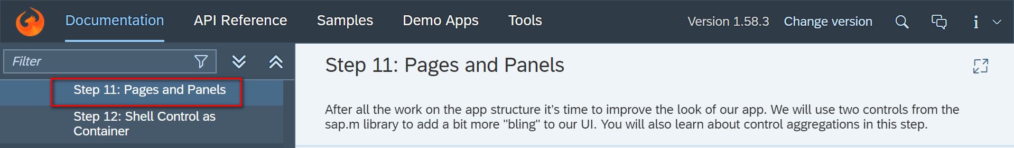

Core Changed Codes Compared to Last Version:

View.

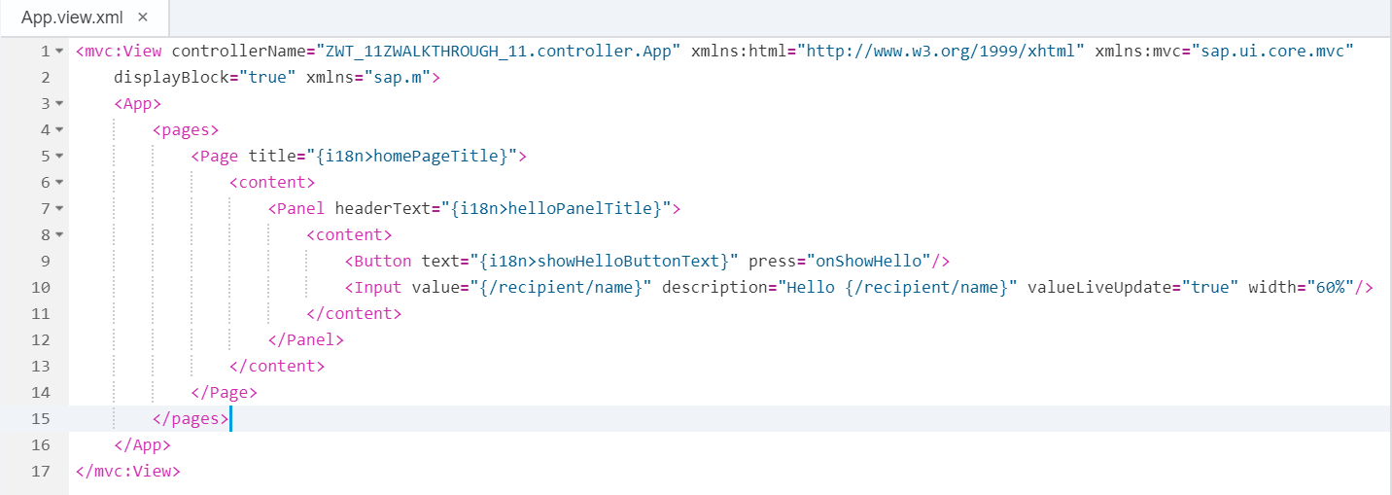

I18n

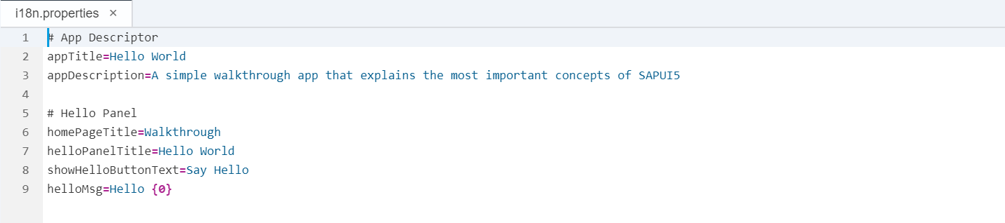

Result:

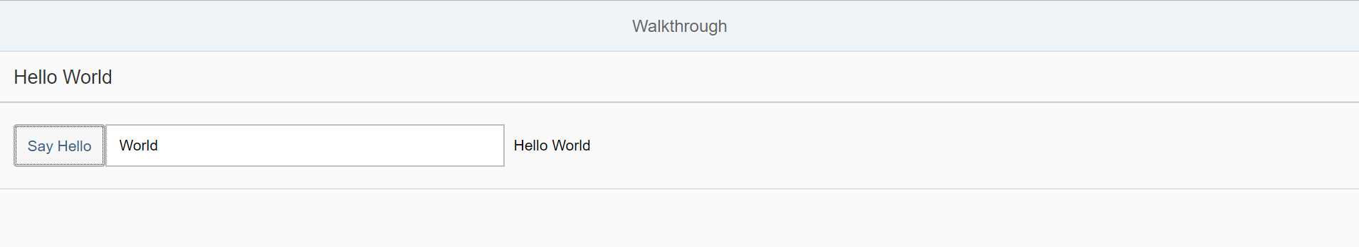

Git:

WALKTHROUGH_11

2018/11/02 XiaoMi Beijing Zac,Xie